# Lab: JavaScript Syntax and Basic Web

Problems for in-class lab for the [JavaScript-For-Front-End](https://softuni.bg/trainings/1795/javascript-for-front-end-october-2017#lesson-7018) @ Softuni

## Calculate

Write a JavaScript program to print the value of the following expression:

* (30 + 25) + ((35 – 14) * 2)

## Bigger Number

Write a JavaScript program with **two numbers** and print bigger of them.

### Examples:

|  |  |  |  |  |
| --- | --- | --- | --- | --- |
| **Input** | **Output** |  | **Input** | **Output** |
| 10  20 | 20 |  | 66  4 | 66 |

### Hints

* Use **If** – **Else** statements

## First 20 Numbers

Write a JavaScript program, which prints first 20 numbers.

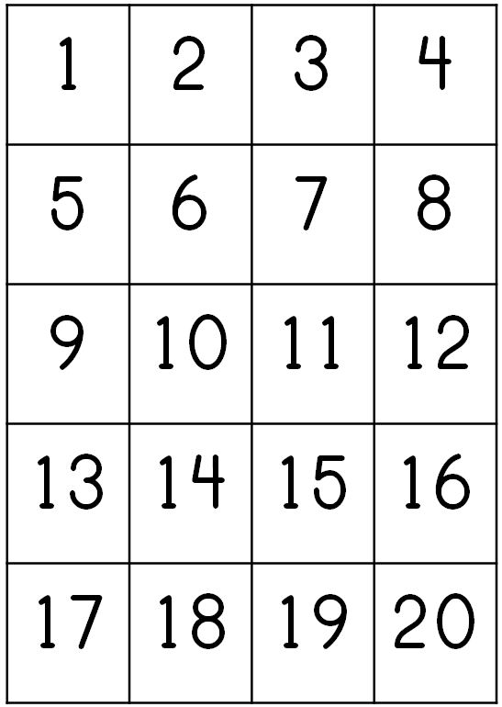

## Print the elements in array

Write a JavaScript program, which print all array elements.

### Examples:

|  |  |
| --- | --- |
| **Input** | **Output** |
| **let numbers = [1, 2, 3, 4, 5];** | 1  2  3  4  5 |

|  |  |
| --- | --- |
| **Input** | **Output** |
| **let sounds = [aaa, ooo, uuu];** | aaa  ooo  uuu |